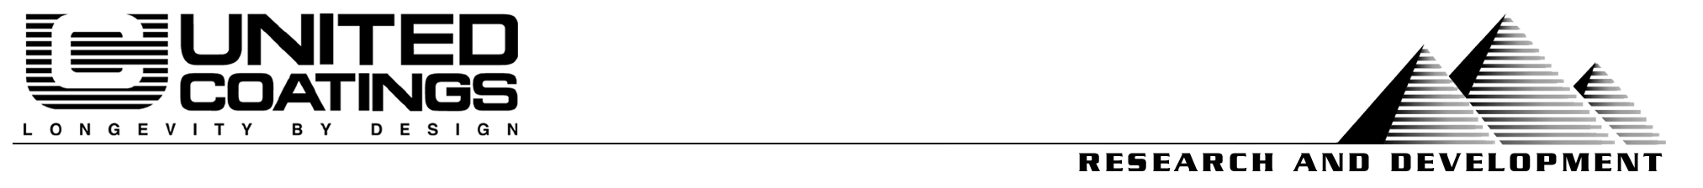
06/04/04
Project & Purpose:
To evaluate UNITED COATINGS’ pedestrian traffic wear-course products using methods useful in their specification and promotion.
Products:
Rhino Top Textured
Rhino Top Smooth
TT-P-19D Control
Procedure:
ASTM D4060 – Standard Test Method for Abrasion Resistance of Organic Coatings by the Taber Abraser
ASTM E303 – Standard Test Method for Measuring Surface Frictional Properties Using the British Pendulum Tester

Ford Motor Company Method BN-108-02 – Scuff Resistance Test
Key Results:
— Friction and Abrasion Results —
Test Method →  Products↓ | Taber Abrasion  ASTM D4060 |  | Ford Scuffing Test  BN-108-02 | Dynamic Friction  ASTM E303
Test Method →  Products↓ | Taber CS-17 Wheel | S-39 (Shoe Leather) | Type “B” Severe | British Pendulum
Rhino Top Textured | 0.075 gram wt. loss | 0.000 gram wt. Loss | 0.014 gram wt. loss | 63.3
Rhino Top Smooth | 0.152 gram wt. loss | 0.000 gram wt. Loss | 0.000 gram wt. loss | ~50
TT-P-19D Control Paint | 0.263 gram wt. loss | 0.000 gram wt. Loss | 0.008 gram wt. loss | 50
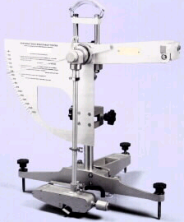
Conclusion:
Compared to premium paint, as defined by the US Government in TT-P-19D, Rhino Top possesses an effective combination of anti-slip and abrasion-resistant properties.
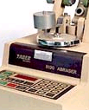Our tests showed that Rhino Top provides over 25% greater grip (British Pendulum) than a flat paint. This test is superior to common static friction measurements in that it determines how easy is it for a moving object to stop, as opposed to measuring the force required to produce slippage. The British Pendulum test is based on the correct assumption that pedestrians, as well as wheels, are moving objects, and that slippage is often an undesirable characteristic.
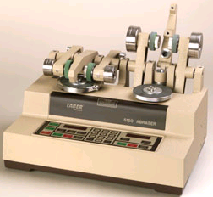
Rhino Top Textured possesses superior abrasion resistance, lasting a minimum of 250% longer than a typical paint under exposure to light abrasives such as urban and residential soils (CS-17 wheel/Taber test). It is also impervious to wear from shoe leather (S-39 wheel/Taber test), exhibiting similar scuff resistance to a smooth paint while also providing a safety-enhancing texture.
Rhino Top Smooth, used alone or in combination with the Textured, also shows improved abrasion resistance as a result of its epoxy fortification. A 73% increase in wear can be expected, as per evaluation using the CS-17 abrasion test. In terms of scuff resistance, Rhino Top smooth shows zero wear according to the Ford Scuff test.

Prepared by:
Steve Heinje | Patty White
VP Research | Compounder
heinje@unitedcoatings.com | patty@unitedcoatings.com
(509) 926-7143 ext. 113 | (509) 926-7143 ext. 141

